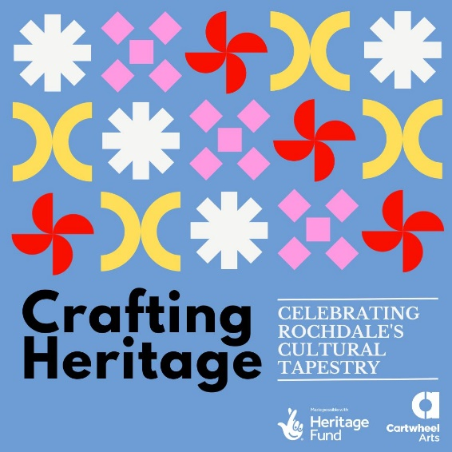
Post Title | Volunteer Archive Assistant – Crafting Heritage, Cartwheel Arts

Volunteering info | Thanks to the generous support of The National Lottery Heritage Fund and Public Health England, we are working on a two-year exploration of the rich heritage crafts flourishing within Rochdale's vibrant communities with experience of forced migration  This will result in:  Crafting Heritage Learning Resource:  A ground-breaking eight-week training programme for four artists who have experienced forced migration  A celebratory event including a film, exhibition and community event for Refugee Week in 2025  The materials created during the project will be archived at Touchstones Rochdale.  The time you can commit can be discussed, this will need to be over the length of the project ending approximately Nov 2006  Post is based at the Cartwheel Arts office and remotely.

Purpose of the role:
To be responsible to the Live & Learn Coordinator for the assistance in archiving the Crafting Heritage Programme.

Key Tasks:
- Researching best practice archiving methods for photographs and film (Digital)
- Assisting in the creation of the Crafting Heritage archiving system
- Cataloguing and listing of outputs from the Crafting Heritage Programme
- Digitisation of archives
- Typing up of transcripts
- Give support to a wide range of promotional events and final exhibition
- To work in line with the company’s policies and must read and work in line with our EDI Policy and our Anti-Discrimination Action Plan.

This opportunity would suit someone who has:
• Good communication and organisational skills
• Excellent ICT skills, Excel and Word
• A passion for Heritage Crafts
• An attention to detail
• knowledge of archival guidelines

We can help you to:
• Acquire basic archival skills and a good knowledge of how an archiving service operates including accession codes.
• Gain experience that can be included in CVs and job applications

We are happy to reimburse any reasonable travel expenses you may incur whilst volunteering with us

Supported by
Cartwheel’s You Live & Learn Coordinator

Please send an expression (no longer than 1 page of A4) of interest to Ruth@cartwheelarts.org.uk
Ruth is also happy to discuss if you have any questions.

